Dress Code for Women
Written by Joe Keim

In Response to Deuteronomy 22:5 and 1 Corinthians 11
Grace, thank you for asking about Deuteronomy 22:5 and 1 Corinthians 11. These scriptures have caused many sincere Christians and churches to divide and go separate ways. Sadly, these divisions often lead to hurt feelings, anger, and bitterness. This deeply grieves the heart of God because Scripture teaches us to live in peace with one another whenever possible.
Let us first look at Deuteronomy 22:5.

Deuteronomy 22:5
“The woman shall not wear that which pertaineth unto a man, neither shall a man put on a woman’s garment: for all that do so are abomination unto the LORD thy God.”
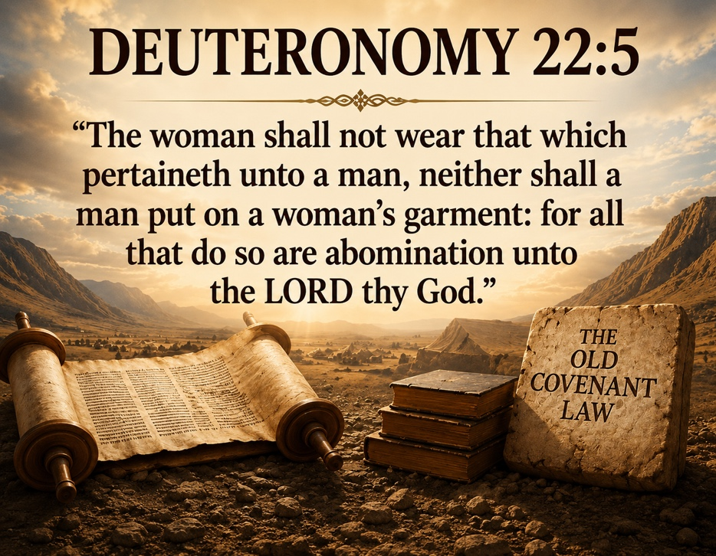
Before we discuss what this verse means, it is important to understand the setting of the Old Testament law.
During Old Testament times, God gave the Israelites thousands of laws and commandments. There were so many that ordinary people could not remember them all. Because of this, certain men were appointed to study, teach, and remind the people about the law.
Deuteronomy 22:5 is only one law among many others given in the Old Covenant. If a person chooses to place himself under one part of the law, then according to Scripture, he must also place himself under the whole law.
Notice several other laws found in the same chapter:
- Deuteronomy 22:11: “Thou shalt not wear a garment of divers sorts, as of woollen and linen together.”
- Deuteronomy 22:12: “Thou shalt make thee fringes upon the four quarters of thy vesture.”
- Deuteronomy 22:21: A woman found guilty of immorality was to be stoned to death.
- Deuteronomy 22:22: A man and woman caught in adultery were both to be put to death.
- Deuteronomy 22:24: Certain sexual sins were punished by stoning.
If we place ourselves under the law of verse 5, then we must also place ourselves under verses 11, 12, 21, 22, and 24.
The New Testament clearly teaches this truth.

The Law Must Be Kept Completely
- James 2:10: “For whosoever shall keep the whole law, and yet offend in one point, he is guilty of all.”
- Galatians 3:10: “Cursed is every one that continueth not in all things which are written in the book of the law to do them.”
According to Scripture, a person who chooses to live under the law must keep every law perfectly. If he breaks even one commandment, he becomes guilty before God.
The problem is this: no human being can keep God’s law perfectly.
- Galatians 3:11-12: “But that no man is justified by the law in the sight of God, it is evident: for, The just shall live by faith. And the law is not of faith.”
The law was never able to make sinners righteous before God. It revealed sin, but it could not remove sin.
Every honest person knows he falls short of God’s perfect standard. None of us are perfect. None of us keep the law completely.
But here is the wonderful news of the gospel:
- Galatians 3:13: “Christ hath redeemed us from the curse of the law, being made a curse for us.”
Jesus Christ took our guilt upon Himself. Through His death on the cross, He redeemed us from the curse that the law placed upon sinners.

The Purpose of the Law


Galatians 3:24-25: “Wherefore the law was our schoolmaster to bring us unto Christ, that we might be justified by faith. But after that faith is come, we are no longer under a schoolmaster.”
The law was given to show us our sin and lead us to Christ. Once we come to Christ by faith, we are no longer under the Old Covenant law system.

Galatians 3:26-28: “For ye are all the children of God by faith in Christ Jesus… There is neither Jew nor Greek… there is neither male nor female: for ye are all one in Christ Jesus.”

So, What Do We Do with Deuteronomy 22:5?
Here is my understanding:

1. To go back to the Old Testament and place myself under the law brings a curse.
- (Galatians 3:10)

2. Christians live under the New Covenant, not the Old Covenant.
- We are made right with God by faith in Jesus Christ, not by keeping Old Testament laws.

3. The New Testament teaches modesty.
- Scriptures such as 1 Timothy 2:9 and 1 Peter 3:3 teach believers to dress modestly and humbly.
- At the same time, we must remember that standards of modesty vary between cultures and countries. What is considered modest in one culture may not be viewed the same in another.

4. Men and women should appear different.
- I believe 1 Corinthians 11:14-15 teaches that there should be a distinction between men and women.

5. Scripture does not specifically command pants for men and dresses for women.
- In Bible times, both men and women commonly wore robe-like garments.

6. My conclusion
- I believe:
  - Men and women should be distinguishable from each other.
  - People should dress modestly.
  - Christians should avoid clothing that is sensual, revealing, or prideful.

What About 1 Corinthians 11?

1 Corinthians 11:16: “But if any man seems to be contentious, we have no such custom, neither the churches of God.”
Remember how we began this study. Good Christians sometimes divide over issues like these, and those divisions often create hurt and bitterness.
The church at Corinth struggled with division too.

1 Corinthians 11:17-18: “Ye come together not for the better, but for the worse… I hear that there be divisions among you.”
The deeper problem in Corinth was not simply head coverings or hairstyles. The real problem was conflict, pride, and division among believers.
Later in the chapter, Paul explains that some believers were spiritually weak because of the way they treated one another.

My Understanding of Head Coverings

1. The church at Corinth included both Jews and Gentiles.
Jewish believers were used to religious traditions and laws. Gentile believers came from pagan backgrounds. Naturally, cultural clashes occurred.

2. Head coverings appear to have been connected to local custom.
Paul concluded the discussion by saying:
- “We have no such custom, neither the churches of God.”
Believers should not fight and divide over customs and outward practices.
The world is full of hurting people who need Christ. There are too many people dying in sin for Christians to spend their lives arguing over external matters.

3. We must choose our battles wisely.
There are some truths worth standing firmly upon, especially concerning salvation and the gospel.
But when it comes to clothing styles, food choices, or cultural customs, believers should show grace, patience, and humility toward one another.
God did not create every person exactly alike.

How Christians Should Treat One Another


1 Corinthians 1:10
“That there be no divisions among you; but that ye be perfectly joined together in the same mind and in the same judgment.”
Sadly, believers do not always agree on every issue. Romans 14 addresses this reality clearly.
Some Christians in Rome believed they could eat all foods. Others believed they should only eat herbs.

Romans 14:2-3: “Let not him that eateth despise him that eateth not; and let not him which eateth not judge him that eateth.”
Some believers considered certain days more important than others.

Romans 14:5: “One man esteemeth one day above another: another esteemeth every day alike. Let every man be fully persuaded in his own mind.”
God teaches us how to handle these differences.

Romans 14:13: “Let us not therefore judge one another anymore.”

Romans 14:15: “Destroy not him with thy meat, for whom Christ died.”

Final Thoughts
According to Romans 14, when differences arise among believers:
- We should not judge one another.
- We should avoid becoming a stumbling block.
- We should pursue peace and spiritual growth.

Romans 14:17-19: “For the kingdom of God is not meat and drink; but righteousness, and peace, and joy in the Holy Ghost. Let us therefore follow after the things which make for peace, and things wherewith one may edify another.”
The kingdom of God is not centered on outward customs, clothing styles, or man-made traditions. It is centered on righteousness, peace, joy, faith in Christ, and love for one another.

Mission to Amish People
575 US Highway 250
Greenwich, OH 44837
Office: (419) 962-1515

