Does God Approve of the Amish Ordinance Letter?
Written by Joe Keim
Do the ordinances and traditions of the Amish church have the same authority as the Word of God? We know what various traditions say about themselves, but what does God’s Word say about the matter?
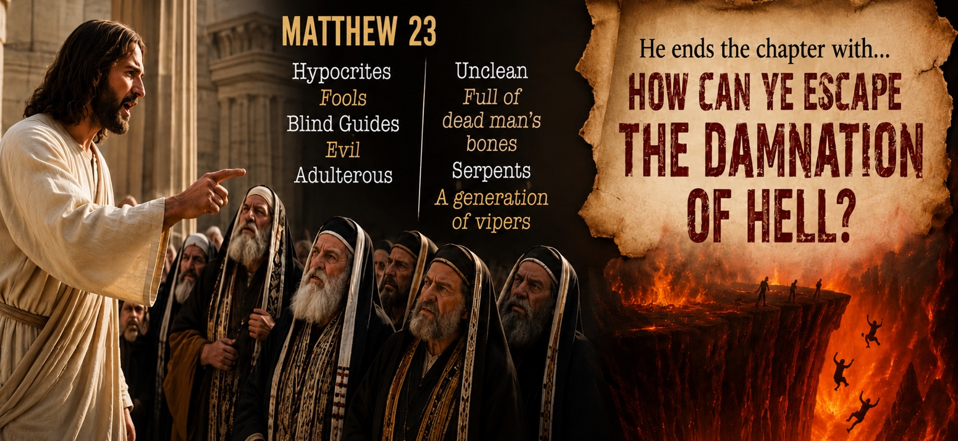
For many years, I believed the Pharisees were extremely evil and wicked people. I thought this because of the strong names Jesus called them. In Matthew 23, Jesus called them hypocrites, fools, blind guides, evil, and adulterous. He also called them unclean, full of dead men’s bones, serpents, and a generation of vipers. He ended the chapter by asking them, “How can ye escape the damnation of hell?”

Those are very serious words. It almost sounds as though these men belonged behind prison bars.
But as I read more about the Pharisees, I began to see another side of them.
Now certainly, there are bad apples in every basket. But what about Nicodemus in John 3? He was a Pharisee, and he seemed sincere enough. What about the apostle Paul? Was he not also a Pharisee? Yes, he was.
In Galatians 1:14, Paul wrote that he was “exceedingly zealous of the traditions of my fathers.” In Philippians 3:5, He described himself this way:
“Circumcised the eighth day, of the stock of Israel, of the tribe of Benjamin, an Hebrew of the Hebrews; as touching the law, a Pharisee.”
Then in verse 6, Paul explained that, according to the righteousness found in the law, he was considered blameless.
Paul sincerely believed that if anyone had things right before God, he did.
This was the problem with many of his people. They had become so strict and so caught up in their religion that they began to feel superior to others. Deep down, they truly believed that if anyone would be accepted by God, it would surely be them.
They wore clothing that made them stand out. They looked and acted very religious, and many people admired them.
One day, the Pharisees noticed that Jesus sat down to eat with tax collectors and sinners (Matthew 9:11). They were shocked. In their minds they thought, “How can a man who claims to be sent from God sit down with sinners?”
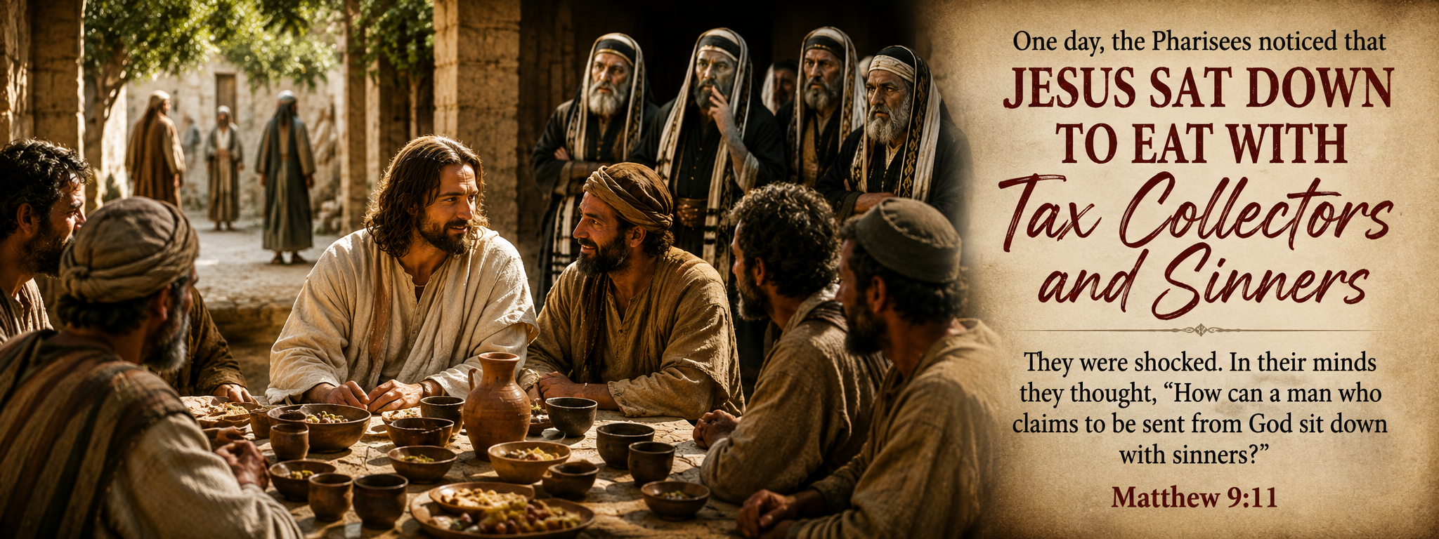
Jesus answered them by saying:
“They that be whole need not a physician, but they that are sick” (Matthew 9:12).
Then He continued:
“I am not come to call the righteous, but sinners to repentance” (Matthew 9:13).
The Pharisees had become so confident in their own righteousness that they failed to see they were opposing the very God they claimed to serve.
One major reason for this was that, over many years, the Jewish leaders had added hundreds of traditions and religious rules to God’s law. Sadly, these traditions became just as important to them as the Word of God itself.
Matthew 23:4 says they “bind heavy burdens” on people’s shoulders, burdens that were difficult to bear.
One example is found in Matthew 15:2. The Pharisees accused Jesus’ disciples of breaking tradition because they ate bread without first washing their hands. They asked Jesus:
“Why do thy disciples transgress the tradition of the elders? For they wash not their hands when they eat bread.”

Thought
Religious people are often disturbed when their traditions, rituals, ceremonies, schedules, and customs are broken. Some become very upset when someone steps outside the accepted pattern.
But notice how Jesus answered them.
In Matthew 15:3 He asked:
“Why do ye also transgress the commandment of God by your tradition?”
Jesus was teaching them that it is possible for man-made traditions to actually work against God’s commands.
A few verses later, Jesus reminded them of Isaiah’s prophecy:
“This people draweth nigh unto me with their mouth, and honoureth me with their lips; but their heart is far from me. But in vain they do worship me, teaching for doctrines the commandments of men” (Matthew 15:8-9).
What had happened? Their religion had become outward and mechanical. It was built on rules, actions, and traditions, while their hearts drifted far from God. As a result, their worship became vain, empty, and fruitless.
In Acts 26, we read how God called Paul to preach salvation to the Gentiles because many of the Jews refused to hear the gospel.
Paul deeply loved his fellow Jews. In Romans 9:2-4 he wrote:
“I have great heaviness and continual sorrow in my heart.
For I could wish that myself were accursed from Christ for my brethren, my kinsmen according to the flesh: who are Israelites…”
Then in Romans 10:1-3, Paul continued:
“Brethren, my heart’s desire and prayer to God for Israel is, that they might be saved.
For I bear them record that they have a zeal of God, but not according to knowledge.
For they being ignorant of God’s righteousness, and going about to establish their own righteousness, have not submitted themselves unto the righteousness of God.”
Paul understood the danger of religious zeal without truth. He once lived that way himself.
At this point, I would like you, the reader, to honestly consider something:
Where do you stand when it comes to the traditions of your fathers? Have traditions and church ordinances become more important to you than the commands of God?
Think carefully about this question:
What holds the Amish church together? What is its true foundation? Is it the Word of God, or is it the Ordnung and church ordinances?
Let us imagine for a moment that the Ordinance Letter was suddenly removed from the Amish church. Would the church continue to stand, or would it begin to fall apart?
Now consider another question:
What would happen if the Ordinance Letter remained, but the Word of God was removed? Would the church continue to stand?

Traditions of Men Create Problems with God

Colossians 2:8-10
“Beware lest any man spoil you through philosophy and vain deceit, after the tradition of men, after the rudiments of the world, and not after Christ.
For in him dwelleth all the fulness of the Godhead bodily.
And ye are complete in him…”

1 Peter 1:18-19
“Forasmuch as ye know that ye were not redeemed with corruptible things, as silver and gold, from your vain conversation received by tradition from your fathers; But with the precious blood of Christ, as of a lamb without blemish and without spot.”

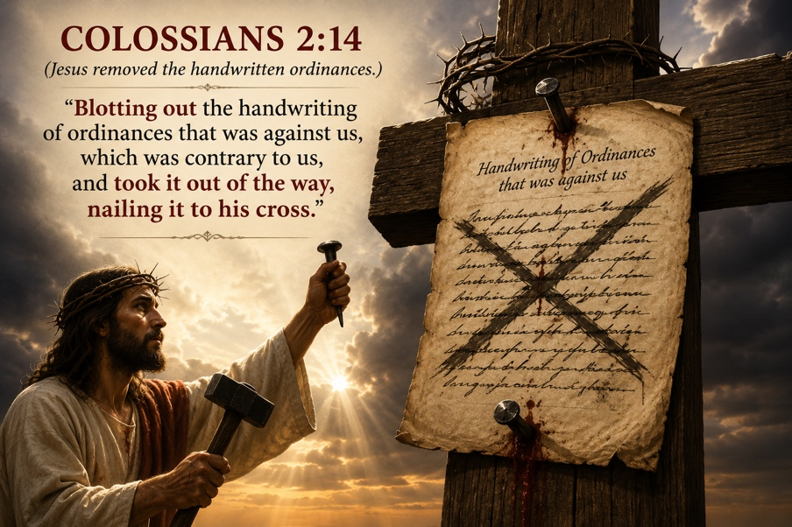
Colossians 2:14
“Blotting out the handwriting of ordinances that was against us, which was contrary to us, and took it out of the way, nailing it to his cross.”

Colossians 2:20-22
“Wherefore if ye be dead with Christ from the rudiments of the world, why, as though living in the world, are ye subject to ordinances,
(Touch not; taste not; handle not;
Which all are to perish with the using;)
after the commandments and doctrines of men?”

After reading “Does God Approve of the Amish Ordinance Letter,” ask yourself:
- Does God support and agree with the Amish ordinance letter?
- Is God pleased when man-made ordinances are placed above His Word?
- Have church traditions become more important to me than the commandments of God?
- Am I trusting in Christ alone for salvation, or am I trusting in religious rules and outward obedience?
- Does the Bible teach that handwritten ordinances bring us closer to God, or does it teach that Jesus nailed them to His cross?
- Am I following the clear teachings of Scripture, or am I following the traditions of men?
- If a tradition cannot be clearly supported by the Word of God, should it still have authority over a Christian’s life?
- Is my relationship with God based on grace and truth, or on fear and religious performance?

Mission to Amish People
575 US Highway 250
Greenwich, OH 44837
Office: (419) 962-1515

