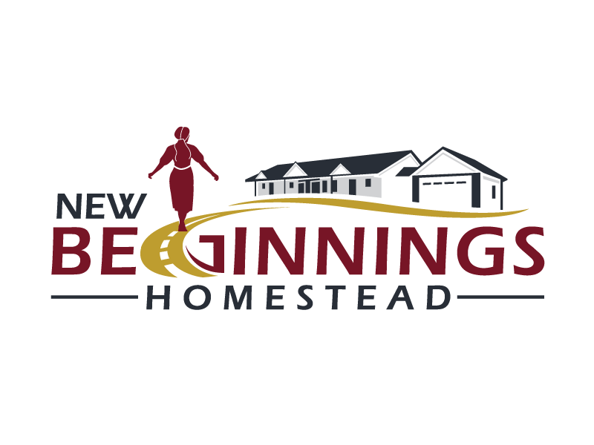

What Can I Expect at New Beginnings Homestead?
New Beginnings Homestead is a safe, Christ-centered residential community where young women leaving the Amish can live while participating in our Pathway to Success Program. You’ll find a supportive environment where women can heal, grow, and prepare for independent living.

What We Provide
- Safe, fully furnished apartment with utilities and free Wi-Fi included
- Private bedroom with bed, desk, and dresser
- Shared bathroom with only one other resident
- Fully equipped kitchen plus washer and dryer
- Employment opportunity at Beyond Measure Market
- Free GED and computer classes
- Weekly life skills classes
- One-on-one mentorship and bi-weekly Bible studies
- Sunday worship at a local church
- Access to Christian counseling
- Assistance obtaining medical insurance and a driver's license
- Access to a ministry-owned vehicle when needed
- Garden space, volleyball, and outdoor recreation
- Apprenticeship & job training
- Financial Literacy classes

What Can You Accomplish in 12 Months?

Months 1–3: Building a Foundation
Focus on stability, personal growth, and establish healthy routines.
You will:
- Create a personalized success plan
- Begin GED preparation (if needed)
- Meet regularly with a mentor
- Receive counseling support
- Learn daily life skills and time management
- Develop healthy routines and goals
- Build relationships within a supportive community

Months 4–6: Developing Skills
Focus on gaining practical tools for independence.
You will:
- Continue GED studies
- Learn budgeting and money management
- Develop computer and technology skills
- Participate in volunteer opportunities
- Explore future career interests
- Practice communication and relationship skills
- Build confidence and personal responsibility

Months 7–9: Preparing for Independence
Focus on applying what you've learned.
You will:
- Work toward GED completion
- Participate in apprenticeships or job training
- Learn employment skills and interview preparation
- Gain hands-on work experience
- Strengthen decision-making and problem-solving skills
- Continue mentoring and personal growth

Months 10–12: Launching Your Future
Focus on long-term success and independent living.
You will:
- Complete your GED (if applicable)
- Secure long-term stable employment, training, or educational opportunities
- Develop a personal financial plan
- Prepare for independent living
- Establish a support network for continued success
- Create goals for your future beyond the program

Community Expectations
Residents agree to participate in Bible studies, mentorship, life skills classes, and community activities. They commit to maintaining a clean apartment, respecting others, and living according to biblical standards. Our code of conduct includes abstaining from drunkenness, sexual immorality, dishonesty, and similar behaviors. Smoking and vaping are prohibited inside the apartments.
Affordable Housing
Residents will pay a low cost monthly Operational Expense after their first 30 days. Operational Expenses follow a tiered schedule:
- Months 2-6: $180
- Months 7-12: $200
- After 1 year: $250
All utilities are included in the Operational Expenses.

Visitors & Safety
Visitors are welcome; however, men are not permitted inside the apartments. Independent living is encouraged so there are no curfews, however, overnight guests require prior approval from leadership, and residents should notify their mentor before staying elsewhere overnight. For added peace of mind, appropriate exterior/common areas are monitored by security cameras with access to individual Ring Cameras at each entry.

A Place to Grow
New Beginnings Homestead is more than a place to live—it is a place to grow. Our desire is to help every resident grow spiritually, emotionally, financially, and practically as she prepares for independent living.
"For I know the plans I have for you," declares the Lord... "plans to give you hope and a future." — Jeremiah 29:11

Interested in Learning More?
We would love to answer your questions and help you determine whether New Beginnings Homestead is the right next step in your journey.

