THE LAMB OF GOD
By Joe Keim
In Genesis chapter 22, God asked Abraham to do something that seems almost impossible for a father to understand.
God told Abraham to offer his beloved son Isaac as a sacrifice.

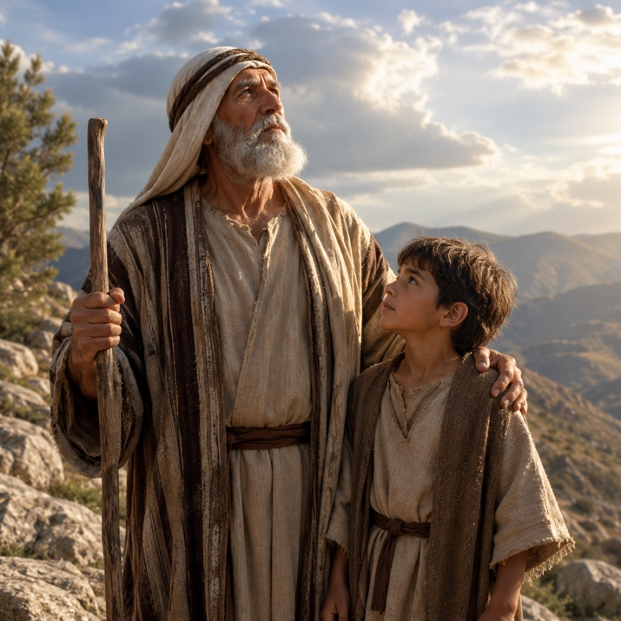
Genesis 22:1-2: “And it came to pass after these things, that God did tempt Abraham, and said unto him, Abraham: and he said, Behold, here I am. And he said, take now thy son, thine only son Isaac, whom thou lovest… and offer him there for a burnt offering upon one of the mountains which I will tell thee of.”
Can you imagine the pain Abraham must have felt?
Isaac was the promised son. He was the son Abraham loved deeply. Yet Abraham obeyed God and made the long three-day journey to the place God had appointed.
When they arrived, Isaac noticed something missing.

Genesis 22:7-8: “And Isaac spake unto Abraham his father, and said, my father… Behold the fire and the wood: but where is the lamb for a burnt offering? And Abraham said, my son, GOD WILL PROVIDE HIMSELF A LAMB for a burnt offering…”
- Those words carried a far greater meaning than Abraham understood at the time.
- This entire story was a picture of something far greater that would happen in the future.
- Isaac was a picture of Jesus Christ.
- Abraham offering his son pointed forward to God the Father offering His Son for the sins of the world.
- And the lamb Abraham spoke about would one day come.

The Promised Lamb
Hundreds of years later, the prophet Isaiah spoke about this coming Lamb.

Isaiah 53:7: “He was oppressed, and he was afflicted, yet he opened not His mouth: He is brought as A LAMB to the slaughter…”
Isaiah was describing Jesus Christ.
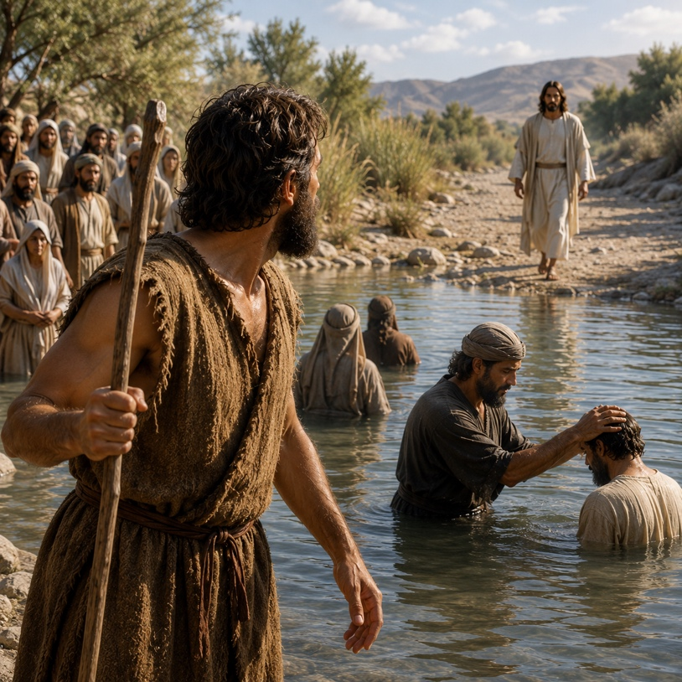
Jesus willingly came to die for sinners. He did not fight back. He did not resist. He willingly gave Himself so mankind could be forgiven.
Many more years passed by and, then one day, the promised Lamb finally appeared.
John the Baptist was baptizing people in the Jordan River when he looked up and saw Jesus’ walking toward him.

John 1:29: “Behold the LAMB OF GOD, which taketh away the sin of the world.”
- What a moment that must have been.
- For centuries, people had sacrificed lambs upon altars. Those sacrifices pointed ahead to the perfect sacrifice that was still to come.
- Now the true Lamb of God had arrived.
- Jesus Christ came to take away the sin of the world.

The Precious Blood of the Lamb
- Jesus was eventually crucified upon the cross.
- He shed His blood so sinners could be redeemed and forgiven.
Years later, the apostle Peter wrote these words:

1 Peter 1:18-19: “Forasmuch as ye know that ye were not redeemed with corruptible things, as silver and gold… But with the precious blood of Christ, as of A LAMB without blemish and without spot.”
- Money cannot save a soul.
- Church traditions cannot save a soul.
- Good works cannot save a soul.
- Only the blood of Jesus Christ can cleanse sin.
- Jesus was the spotless Lamb of God.
- He was perfect, holy, and without sin.

The Lamb in Heaven
The apostle John later received a vision while he was exiled on the Isle of Patmos.
He saw heaven opened and saw the Lamb of God being worshiped.

Revelation 5:12-13: “Worthy is the Lamb that was slain to receive power, and riches, and wisdom, and strength, and honour, and glory, and blessing…”
- One day every creature in heaven and earth will acknowledge Jesus Christ as Lord.
- The Lamb who was rejected by many on earth will one day be worshiped by all creation.

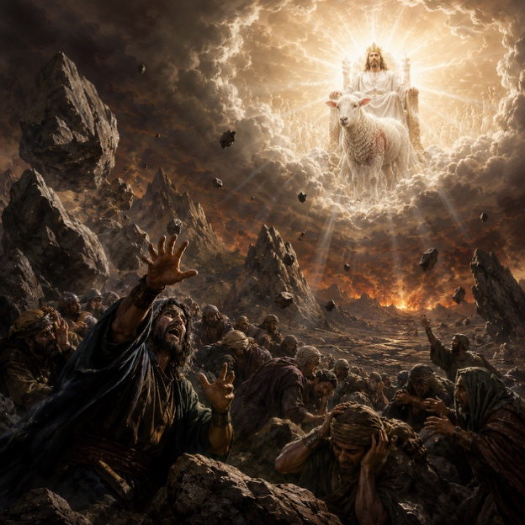
The Wrath of the Lamb
John also saw a future day of judgment.

Revelation 6:15-17: “And said to the mountains and rocks, fall on us, and hide us from the face of him that sitteth on the throne, and from THE WRATH OF THE LAMB…”
- The same Lamb who lovingly died for sinners will one day judge the world.
- Many people reject Jesus today, but someday every man and woman will stand before Him.
- No one will escape that day.

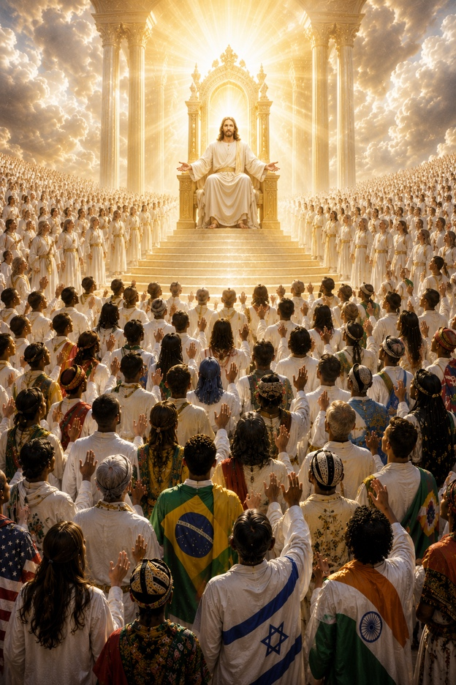
The Saved Standing Before the Lamb
But there is wonderful news for those who trust in Christ.

Revelation 7:9-10: “A great multitude, which no man could number, of all nations, and kindreds, and people, and tongues, stood before the throne, and BEFORE THE LAMB…”
People from every nation and language will stand before Jesus clothed in white robes because their sins have been washed away by His blood.
What a beautiful picture of salvation.

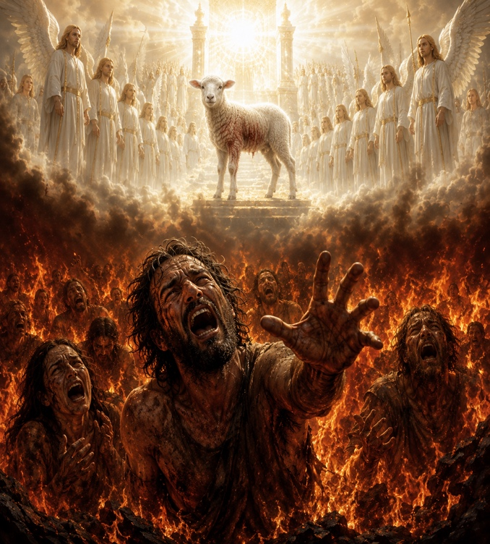
Two Eternal Destinations
- The Bible teaches there are only two eternal destinies.
- Those who reject Christ will face eternal judgment.

Revelation 14:10: “…he shall be tormented with fire and brimstone in the presence of the holy angels, and in the PRESENCE OF THE LAMB.”
But for those who belong to Christ, heaven awaits.

Revelation 21:22-23: “For the Lord God Almighty and the Lamb are the temple of it… and THE LAMB IS THE LIGHT thereof.”

Revelation 22:1: “And he shewed me a pure river of water of life… proceeding out of the throne of God and of THE LAMB.”
What a glorious future for those who know Jesus Christ.

Three Important Questions
- Will you be there?
- Are you sure you are right with God?
- What if you are wrong for all eternity?
The answers to these questions are not found in:
- human tradition,
- church membership,
- or the teachings of men.
The answers are found in the Bible. That is why we must read the Word of God carefully.

What the Bible Says About Sin
- James 1:15: “Sin, when it is finished, bringeth forth death.”
- Romans 6:23a: “For the wages of sin is death…”
- Romans 5:12: “…death passed upon all men, for that all have sinned.”
Every person has sinned against God. And sin brings death and separation from God.

The Good News
But the Bible also gives wonderful hope.
- John 11:25: “I am the resurrection, and the life: he that believeth in me, though he were dead, yet shall he live.”
- 2 Timothy 1:10: “Jesus Christ… hath abolished death, and hath brought life and immortality to light through the gospel.”
- Romans 6:23b: “…but the gift of God is eternal life through Jesus Christ our Lord.”
- 1 John 5:11-13: “And this is the record, that God hath given to us eternal life, and this life is in his Son…”
God offers eternal life through Jesus Christ.

Jesus Is Calling Your Name Right Now
- Jesus lovingly calls sinners to Himself.
- Jesus wants to forgive your sins and give you eternal life.
- Will you open the door of your heart to Him?

Will You Receive Him?
- John 1:11-13: “He came unto his own, and his own received him not. But as many as received him, to them gave he power to become the sons of God…”

  - Some people reject Jesus.
  - Others receive Him by faith and become children of God.
  - Which one will you be?

Final Thought
- Jesus Christ is the Lamb of God.
- He came into this world to die for sinners.
- He rose again from the dead.
- And one day He will return as King and Judge.
- Today He offers forgiveness, mercy, and eternal life to all who trust in Him.
- Do not reject the Lamb of God.
- Come to Him while there is still time.

Mission to Amish People
575 US Highway 250, Greenwich, OH 44837
Office: (419) 962-1515

